PROJECT REPORT ON
“DATA SPARK: ILLUMINATING INSIGHTS FOR GLOBAL ELECTRONICS”

ABSTRACT
This report summarizes the analysis of customer, product, sales, store, and currency data for Global Electronics. The aim was to uncover actionable insights that could enhance customer satisfaction, optimize operations, and drive overall business growth. The analysis included data cleaning, integration, and visualization, along with SQL queries to extract key insights. The findings and recommendations provided in this report are intended to support strategic decision-making for Global Electronics.

INTRODUCTION
Global Electronics, a leading retailer in consumer electronics, has a vast array of customer, product, sales, and store data that holds valuable insights for driving business growth.
This project, “Data Spark: Illuminating Insights for Global Electronics” focuses on leveraging these datasets to provide Global Electronics with a comprehensive understanding of customer preferences, sales trends, and store performance. The findings in this report are designed to inform strategic decisions across marketing, inventory management, pricing, and store operations.

OBJECTIVES
- Enhance marketing strategies
- Optimize inventory management
- Improve sales forecasting
- Develop better products
- Plan effective promotions
- Decide on store expansions and optimizations
- Understand the impact of currency exchange rates on sales

DATASETS
The datasets provided for analysis included:
- Customers: Information about customer demographics and purchasing behavior.
- Products: Details about the products sold, including categories and specifications.
- Sales: Transaction data capturing sales details.
- Stores: Information about store locations and performance metrics.
- Currency Exchange Rates: Historical exchange rates relevant to our international sales.

DATA CLEANING AND INTEGRATION
The data underwent extensive cleaning and integration processes, which included handling missing values, converting data types, and merging datasets to create a unified dataset for analysis. This ensured the accuracy and reliability of the insights derived from the data.

LIBRARIES USED
The following Python libraries were used to conduct the analysis:
- Pandas (import pandas as pd): For data handling, cleaning, and merging operations.
- Matplotlib (import matplotlib.pyplot as plt): For plotting sales, demographic distributions, and purchasing trends.
- Seaborn (import seaborn as sns): For advanced visualizations such as violin plots and heat maps, enhancing data insights.
These libraries facilitated efficient data processing and visualization, aiding in both the EDA and final report preparation.

ANALYSIS OVERVIEW
Various analytical techniques were employed to visualize and understand the data, including graphical representations of:
- Age distribution of customers
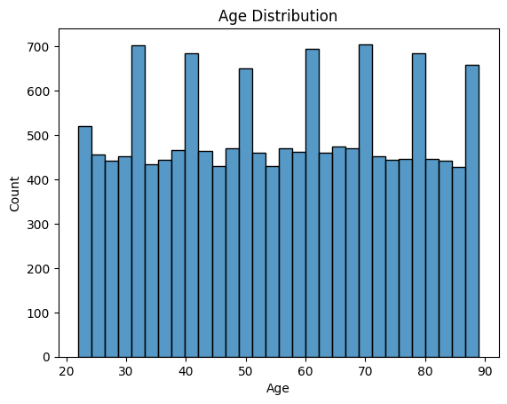
- Preferred products based on sales data
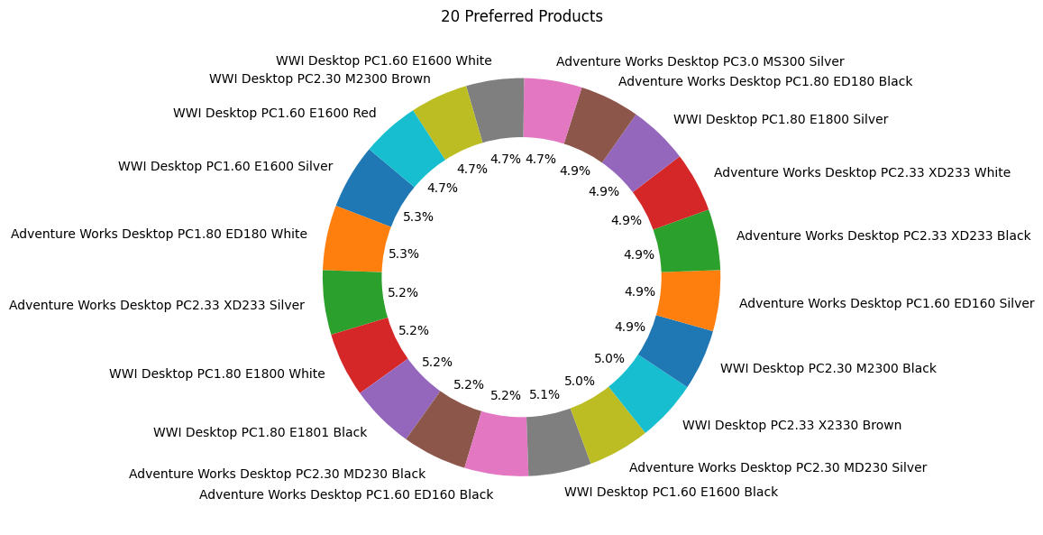
- Sales performance by currency
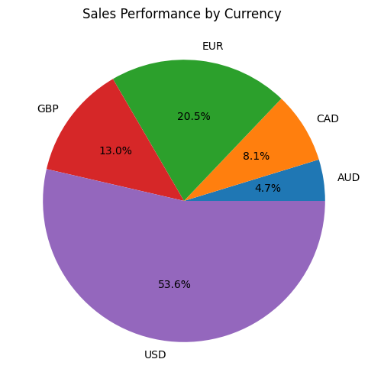
- Profit margins across products
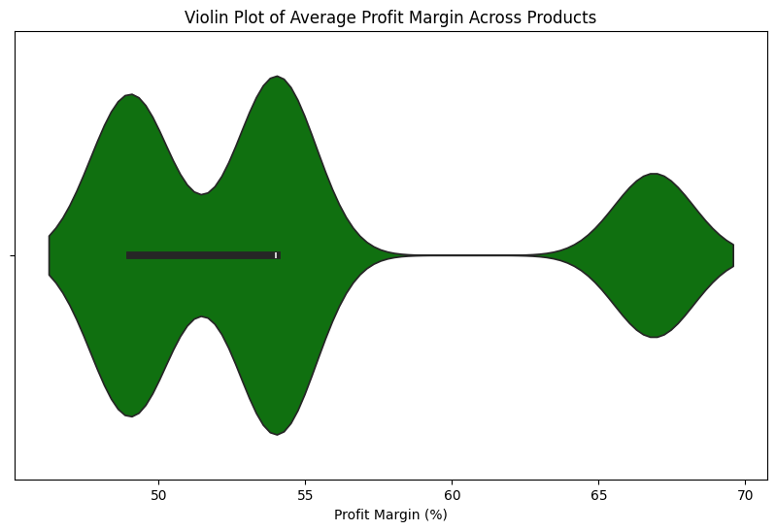

- Total quantity sold by product category
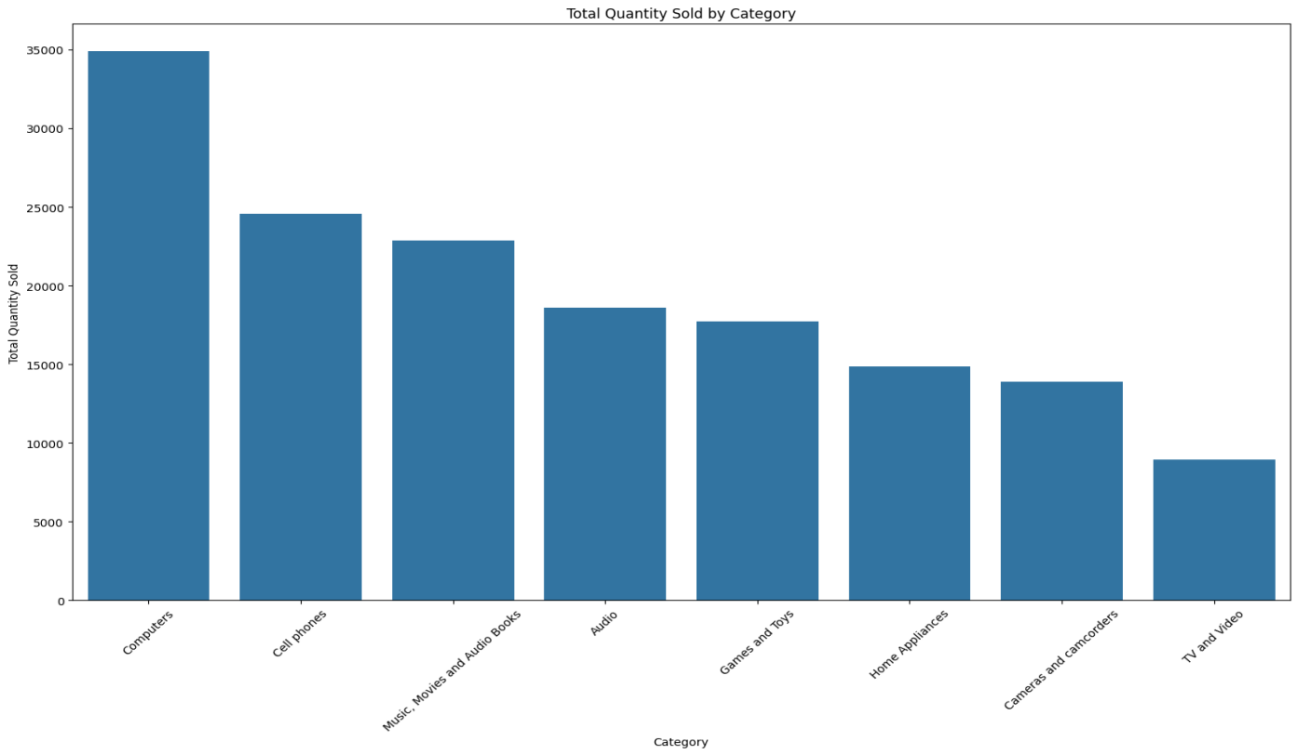

Power BI dashboards were also developed for a deeper exploration of customer behaviors, product sales, and store performance. This interactive platform enabled stakeholders to view and analyze trends dynamically.
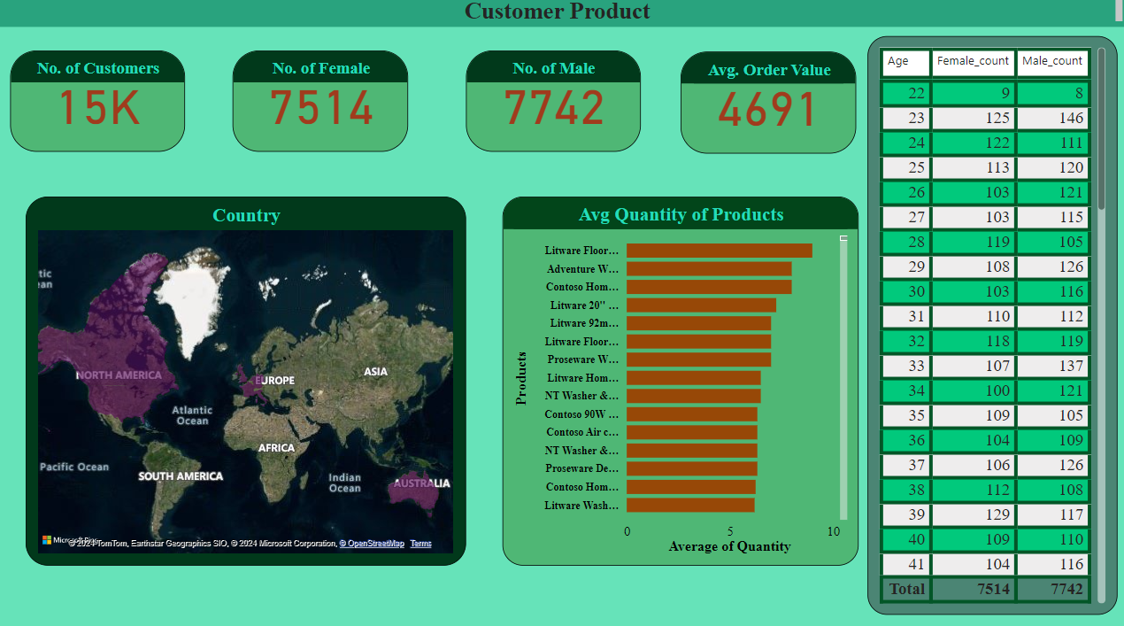
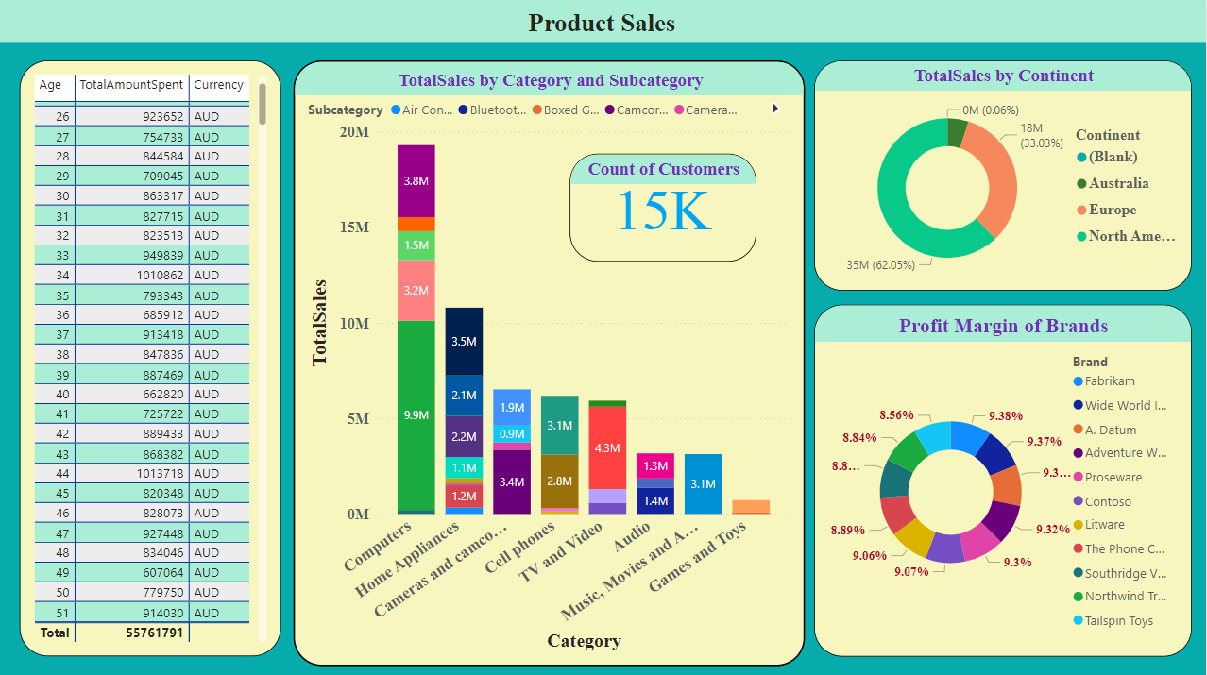

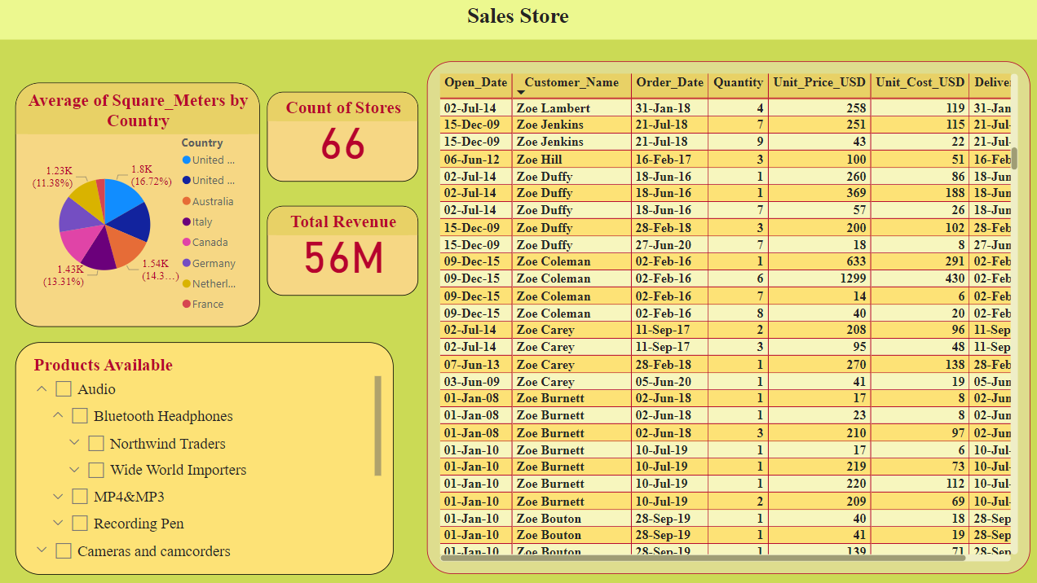

RECOMMENDATIONS
Based on these insights, the following recommendations are made:
- Targeted Marketing: Develop campaigns focused on identified demographic segments with high purchasing activity.
- Strategic Product Promotions: Emphasize high-demand and high-margin products in promotional strategies to enhance profitability.
- Dynamic Pricing Strategy: Implement pricing adjustments for international sales to address currency fluctuation impacts.
- Inventory Management: Optimize stock levels based on popular items and seasonal trends to balance supply with demand.
- Store Expansion Strategy: Expand successful store models in high-performing regions to capitalize on growth potential.

CONCLUSION
The analysis yielded significant insights that can be leveraged to enhance marketing strategies, optimize inventory management, and improve sales forecasting. The findings underscore the importance of data-driven decision-making in the retail electronics sector.

REFERENCE
https://docs.google.com/document/d/1tuymhldQHILji4smwQzJQ4XHMuaHZ4aYx16FsV-Ff18/edit?usp=sharing

DECLARATION
I declare that, this report is prepared by Mirthu Baashini B, Data Science Student at Guvi,
Batch MDE95.

